**Module-9: Kubernetes Assignment - 5**

You have been asked to:

● Use the previous deployment

● Deploy an nginx deployment of 3 replicas

● Create an nginx service of type clusterip

● Create an ingress service /apache to apache service /nginx to nginx service

We used previous assignment nginx service

And now created service for apache by cmd instead of yaml file

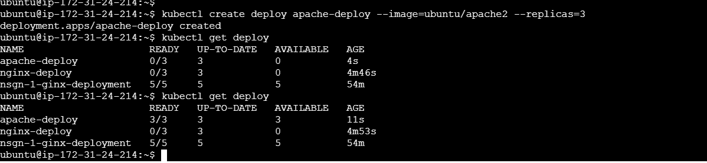

Create clusterIP for the apache service

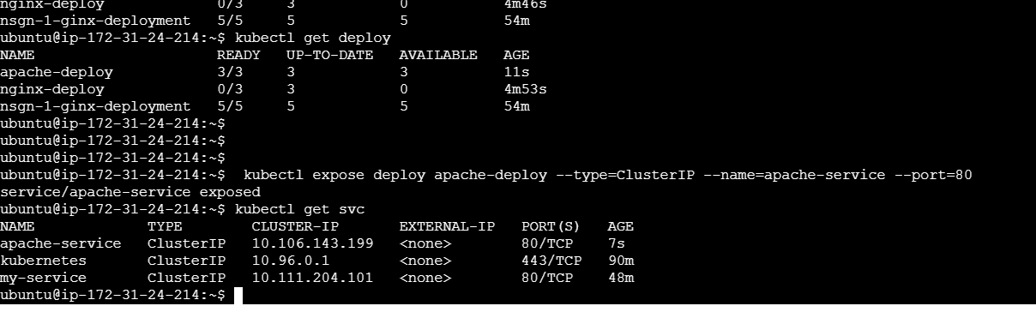

Now create the Ingress yaml file

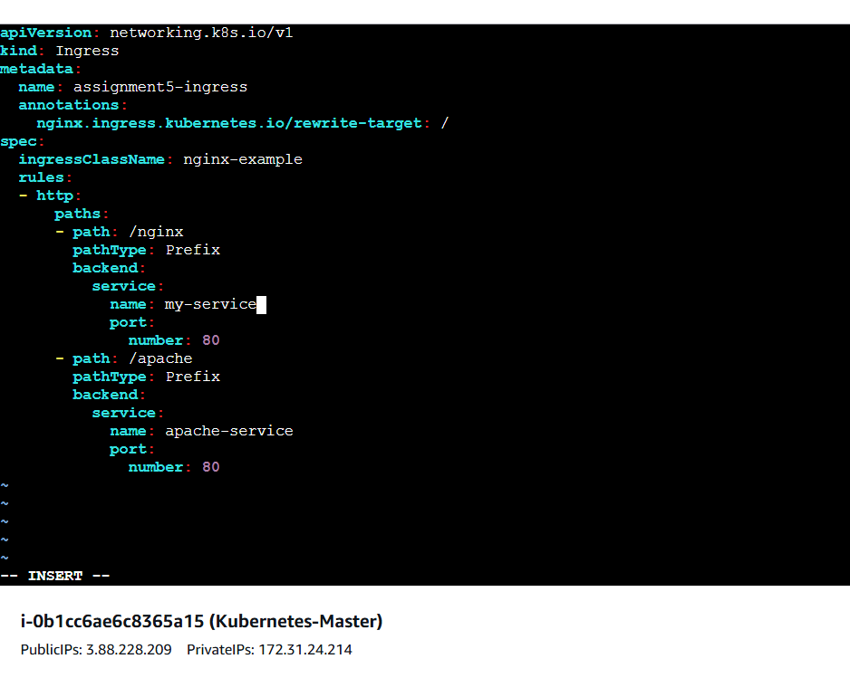

To verify ingress created

